**Objective Answers:**

1. **What is the total number of attributes in the customer table?**

The customers table has 3 attributes: CustomerID, CustomerAge, CustomerGender.

1. **How will you get the “Customer’s” ages in the “Order” tables according to customer IDs?**

In the Data view, select the Orders table.

* Click on Modeling in the top menu and then select New column.
* CustomerAge = RELATED(Customers[Customer Age])

1. **In analyzing the dataset with Power BI, ensure data cleaning to address inconsistencies and missing values before further analysis.**

In Power BI, we use Power Query Editor to:

* + Removing duplicates.
  + Handling blank rows by removing it.
  + Ensuring data types are correct.
  + Removing extra blank columns.

1. **How can we calculate the total revenue generated by all the sales?**

**Reference:**

The total revenue generated by all sales is as follows:

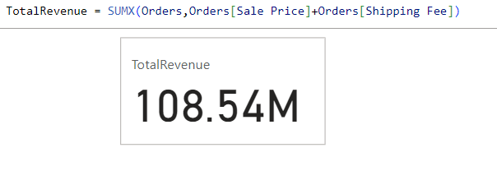

1. **What is the total number of unique customers who made purchases each year? Is there any increase in the number over the years?**

**References:**

The total no. of unique customers who made purchases each year as follows:

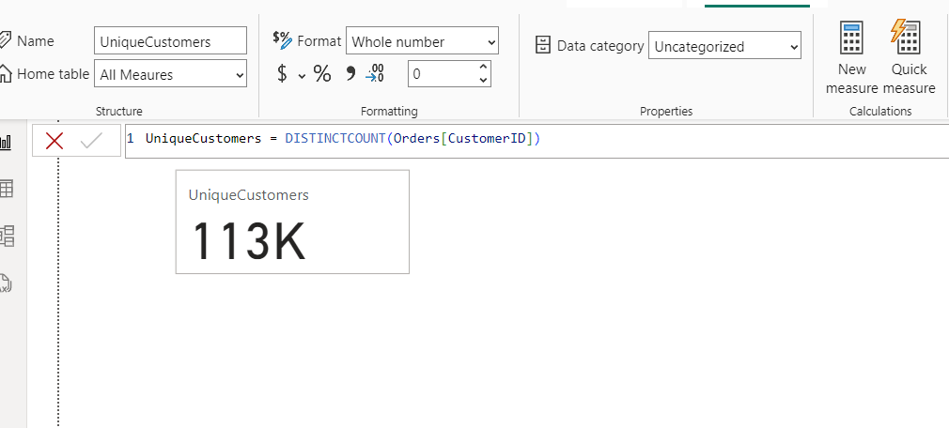

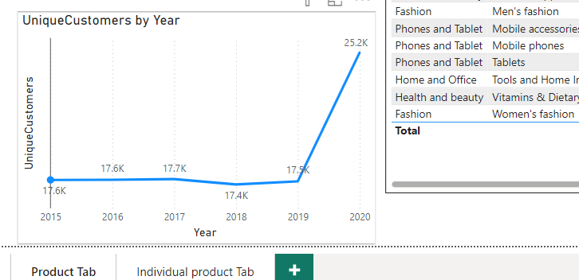

**Insights:**

* Here, the unique customer count shows a steady increase from 2019 to 2020, this indicate that successful marketing strategies or an expanding product range that attracts new customers.
* A year with a slight drop from year 2017 to 2018 can be into potential issues like product availability, pricing changes, or increased competition.

1. **How can we determine the total number of unique products available in the company?**

**Reference:**

The total no. of unique products as follows:

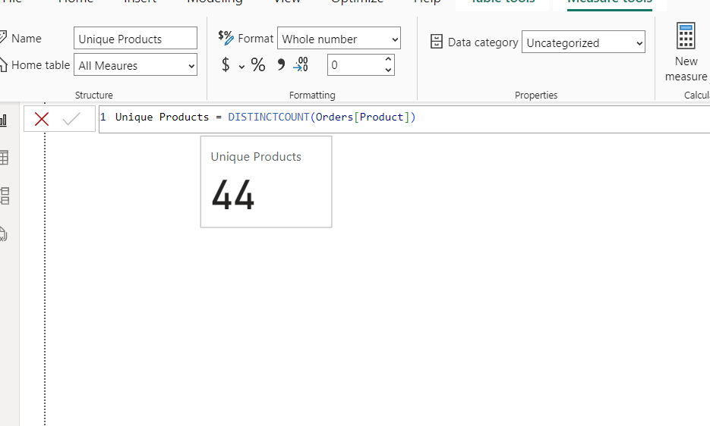

1. **What is the average number of days it takes for products to be delivered, get the metric for only the delivered orders.**

**Reference:**

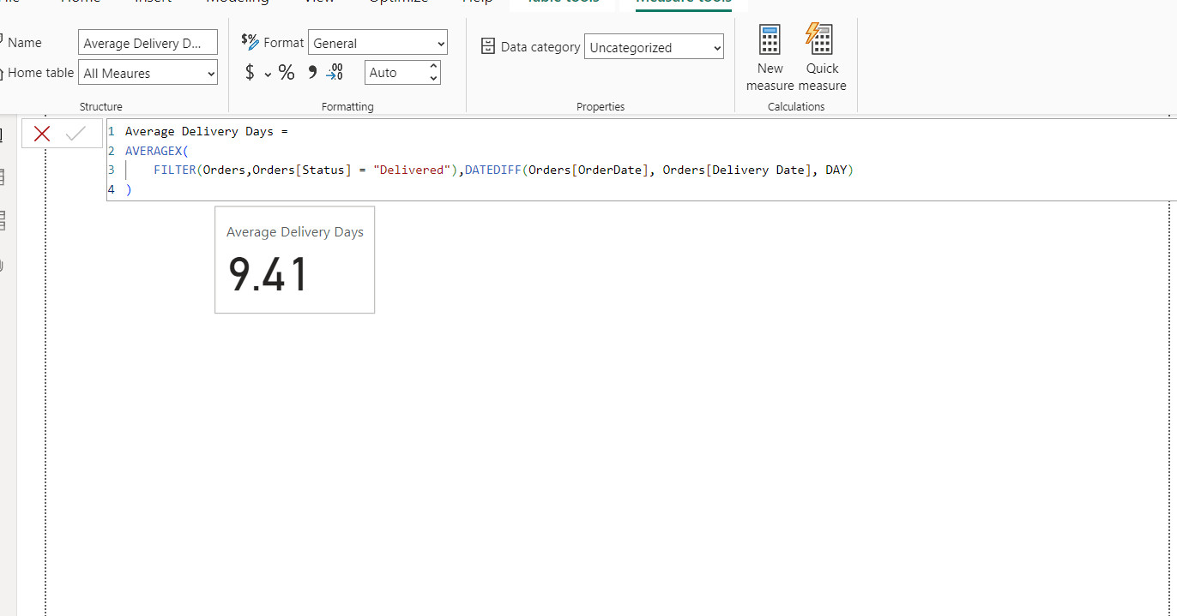

1. **Which products, categories, and subcategories are the most popular?**

**Reference:**

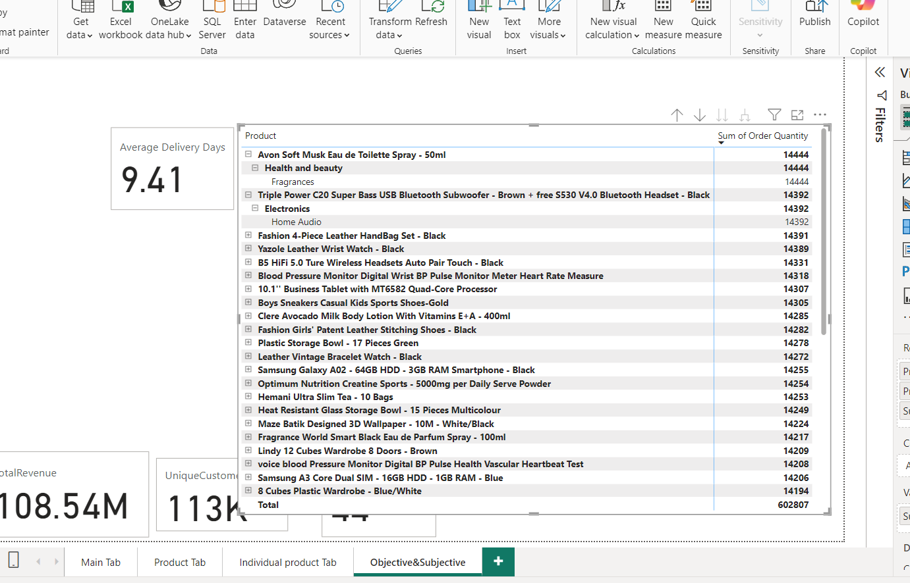

1. **Which products have seen an increase or decrease in sales over the year?**

**Reference:**

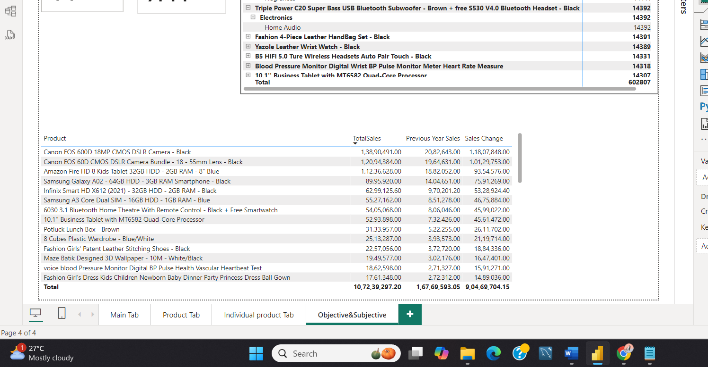

1. **While modeling the data relationships, what will be the type of relationship between the customer ID of Orders and customer tables?**

**Reference:**

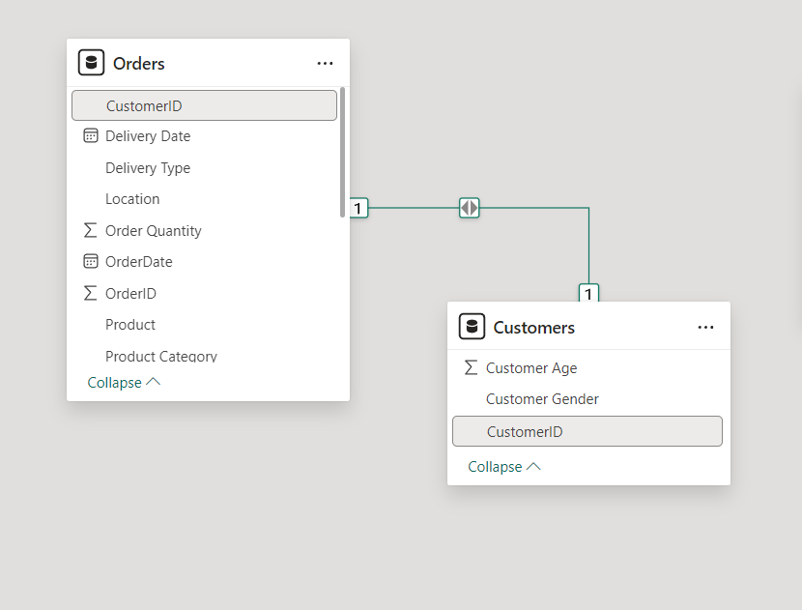

* While modelling the data relationships, the type of relationship between the customer ID of Orders and Customer tables is **one to one relationship**.

1. **How have you handled the null values in the data?**

* Use of Power Query Editor to filter out or remove null values.
* Use of Power Query Editor, if any blank rows are present which helps to remove the bottom/top rows.
* If any blank values in our data, then we create a measure:

Sale Price Cleaned = IF(ISBLANK(orders[Sale Price]), 0, orders[Sale Price])

By using above measure, our data will not be modified or no changes in our values will be affected.

1. **Were there any data format issues in the data, and if there were/are how you would handle them?**

* In our data, there was no need to change the data types.
* If there was such an issue to format the datatypes then I can check and transform data types in the Power Query editor.
* Where the use of Power Query editor is to change data types where necessary (e.g., dates are recognized as date types, numerical values as numbers, text in string format).

1. **When we add a column in Power Query what’s the code that comes in M language in the formula bar? What do you know about M-query?**

When we add a column in Power Query, the code that comes in M language in the formula bar is as follows:

**Syntax:**

= Table.AddColumn(PreviousStep, "NewColumn", each [Column1] + [Column2])

**Example:**

= Table.AddColumn(#"Removed Blank Rows", "Custom", each null)

**Reference:**

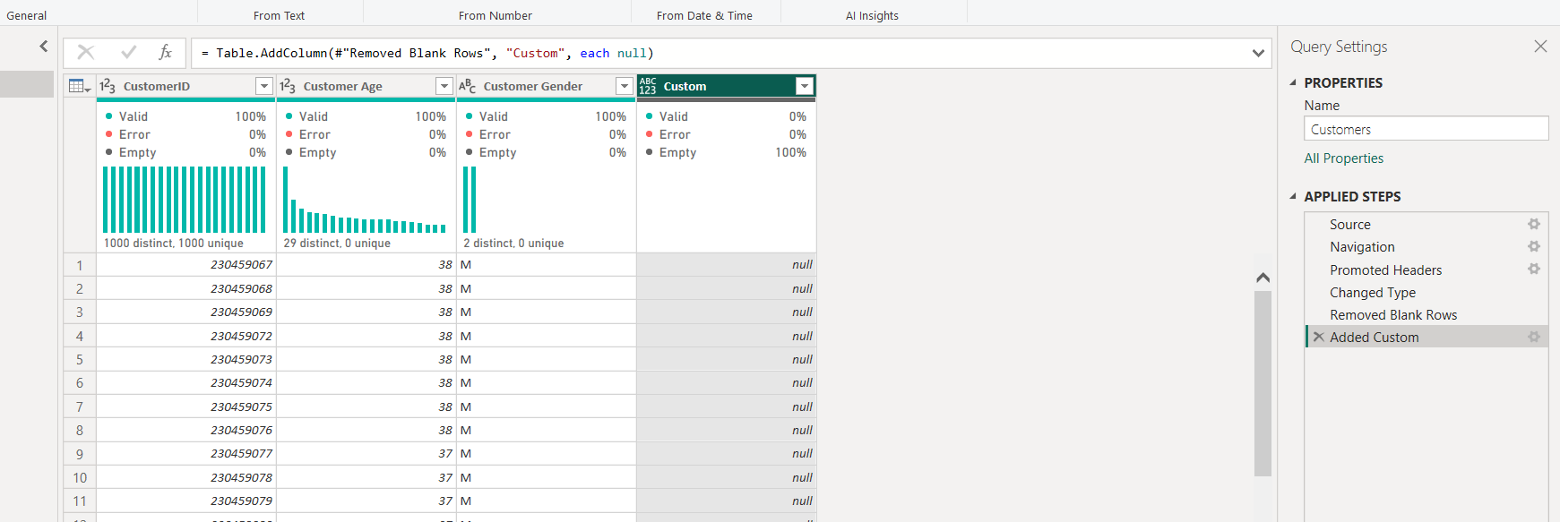

**About M-Query**: M is a functional language used in Power Query for data transformation and cleaning tasks. It allows for the creation of custom queries to manipulate data before loading it into the Power BI model.

1. **Identify the top 5 most valuable customers using a composite score that combines three key metrics: (SQL)**
2. **Total Revenue (50% weight): The total amount of money spent by the customer.**
3. **Order Frequency (30% weight): The number of orders placed by the customer, indicating their loyalty and engagement.**
4. **Average Order Value (20% weight): The average value of each order placed by the customer, reflecting the typical transaction size.**

**Reference:**

The top 5 valuable customers as follows:

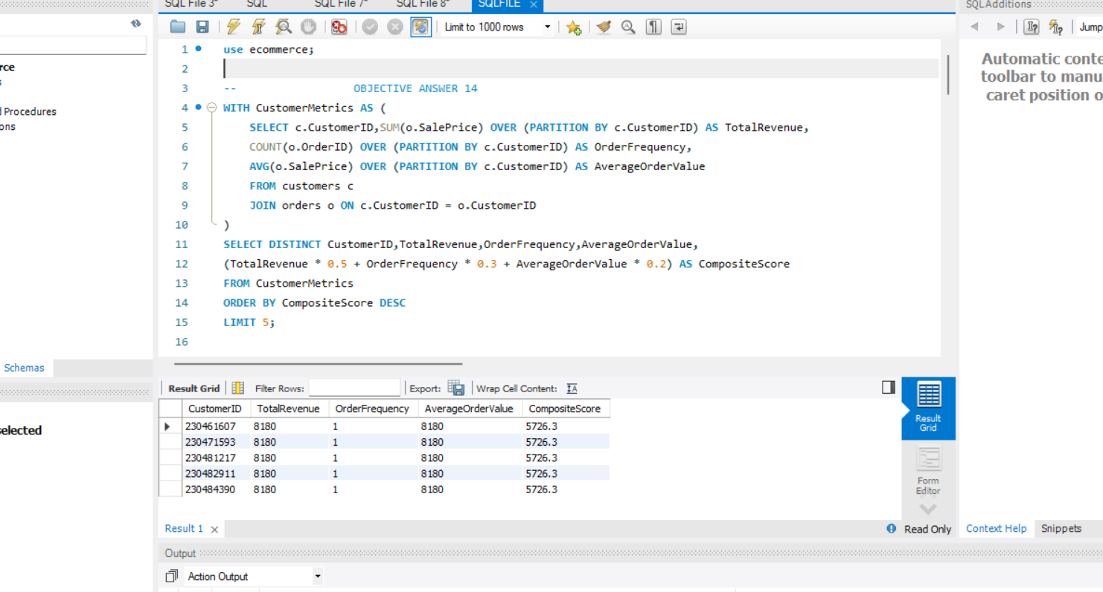

1. **Calculate the month-over-month growth rate in total revenue across the entire dataset. (SQL)**

**Reference:**

The month-over-month growth rate in total revenue as follows:

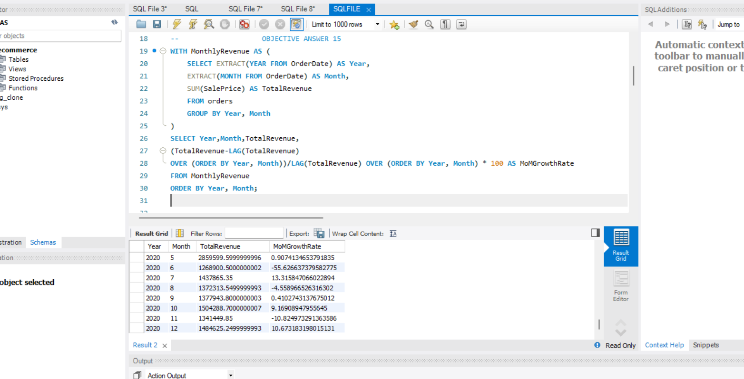

1. **Calculate the rolling 3-month average revenue for each product category. (SQL)**

**Reference:**

The rolling 3-month average revenue for each product category as follows:

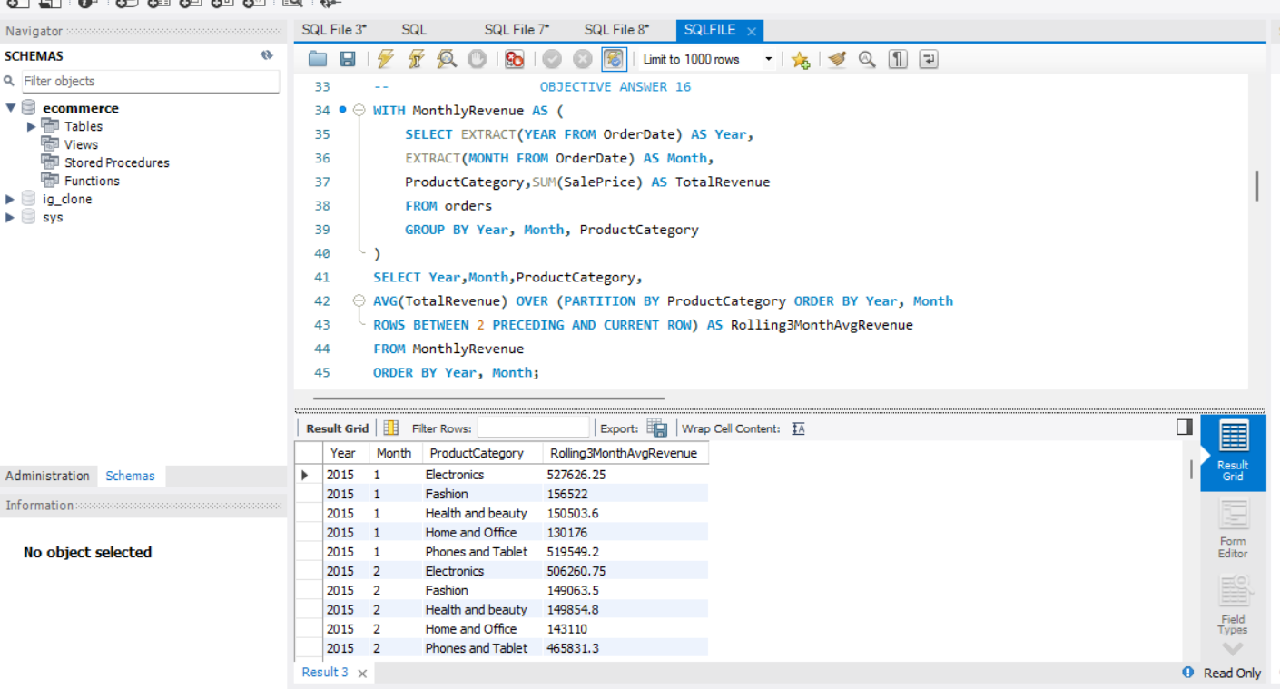

1. **Update the orders table to apply a 15% discount on the `Sale Price` for orders placed by customers who have made at least 10 orders. (SQL)**

**Reference:**

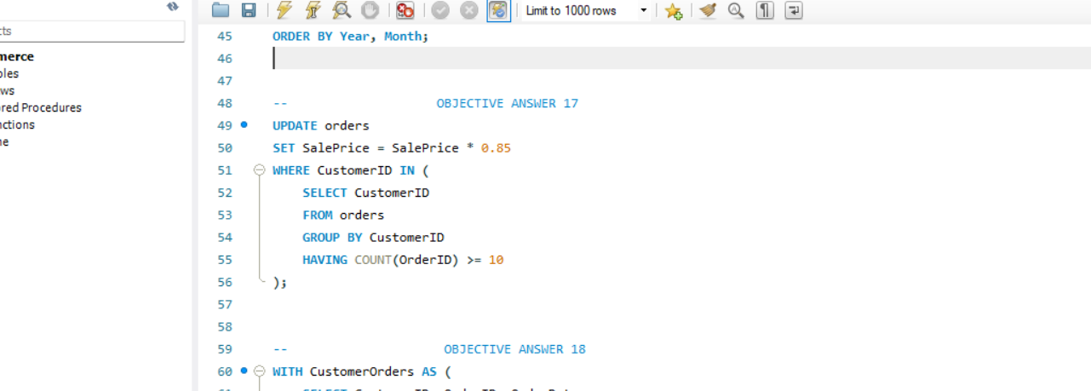

1. **Calculate the average number of days between consecutive orders for customers who have placed at least five orders. (SQL)**

**Reference:**

The average no. of days between consecutive orders as follows:

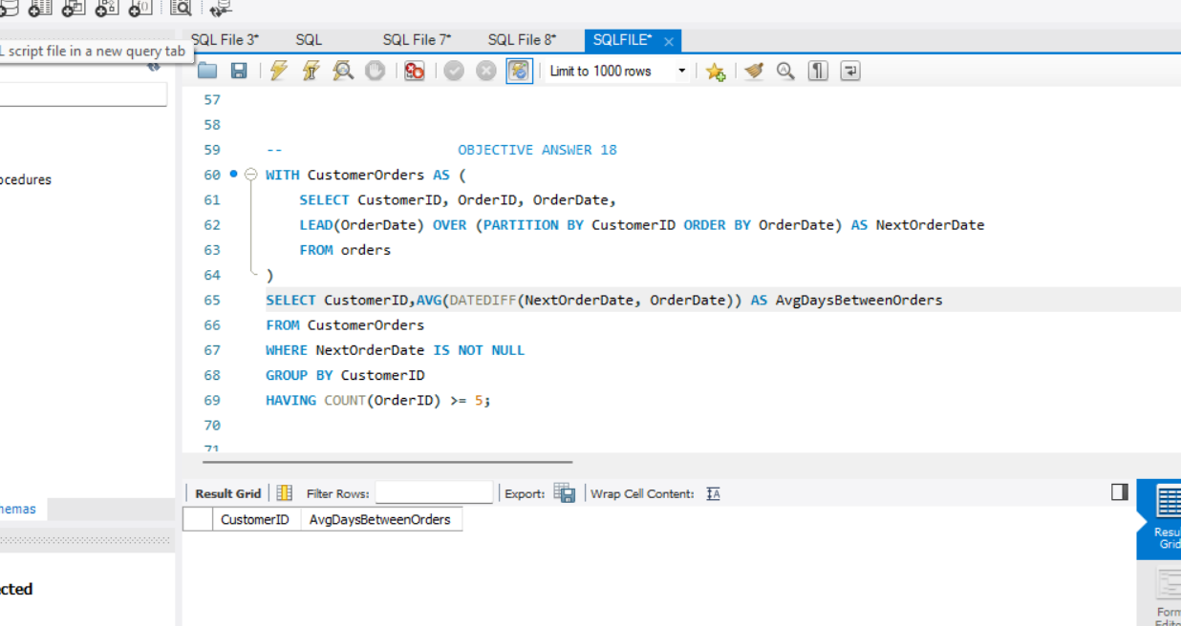

1. **Identify customers who have generated revenue that is more than 30% higher than the average revenue per customer. (SQL)**

**Reference:**

The revenue which is more than 30% higher than average revenue as follows:

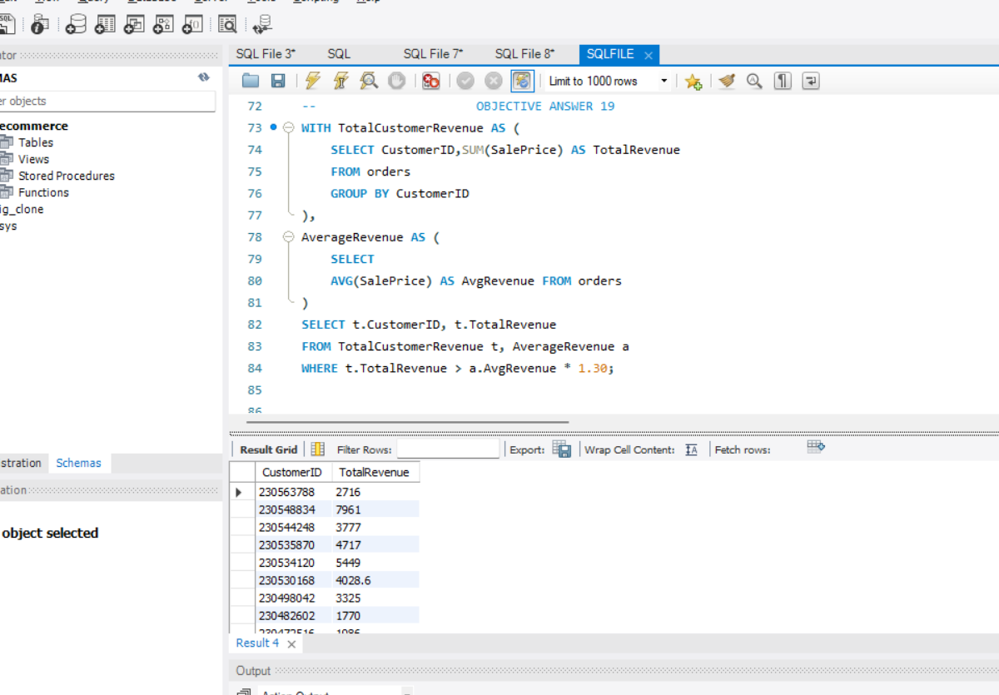

1. **Determine the top 3 product categories that have shown the highest increase in sales over the past year compared to the previous year. (SQL)**

**Reference:**

The top 3 product categories which have highest increase in sales over past year as follows:

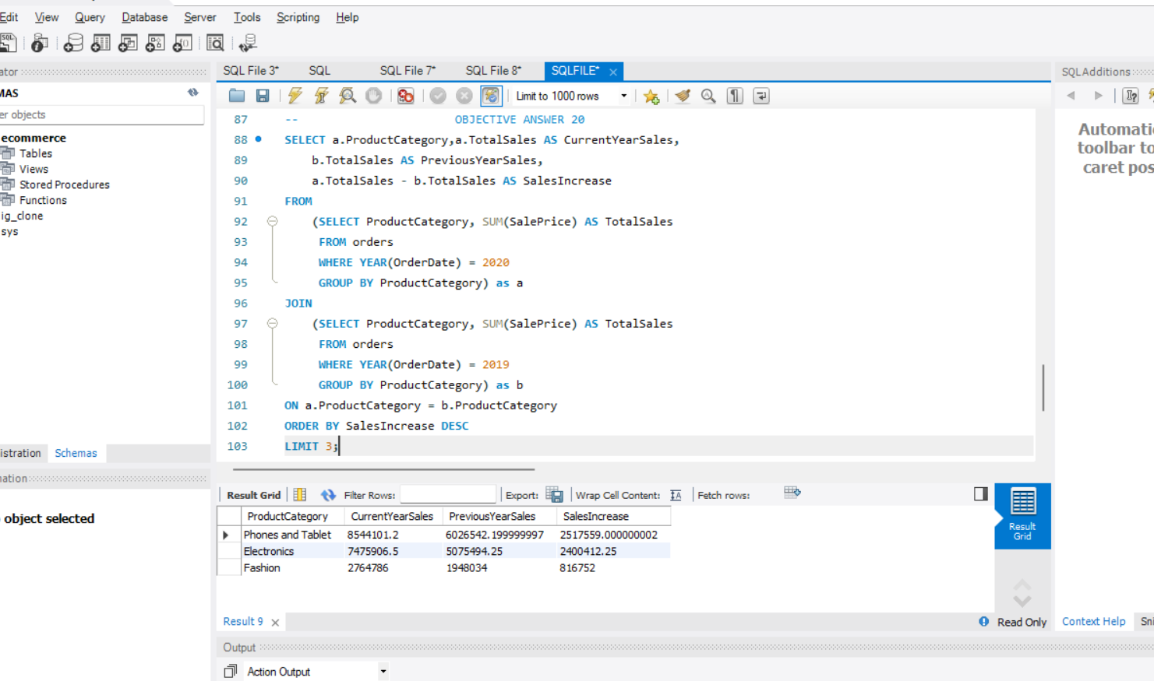

**Subjective Answers:**

1. **Explain the revenue breakdown by year and by-product. Evaluate how different products contribute to annual revenue and come up with suggestions to increase the sales of the low-selling items.**

**References:**

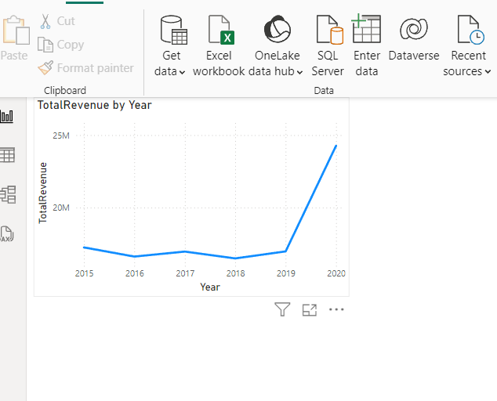

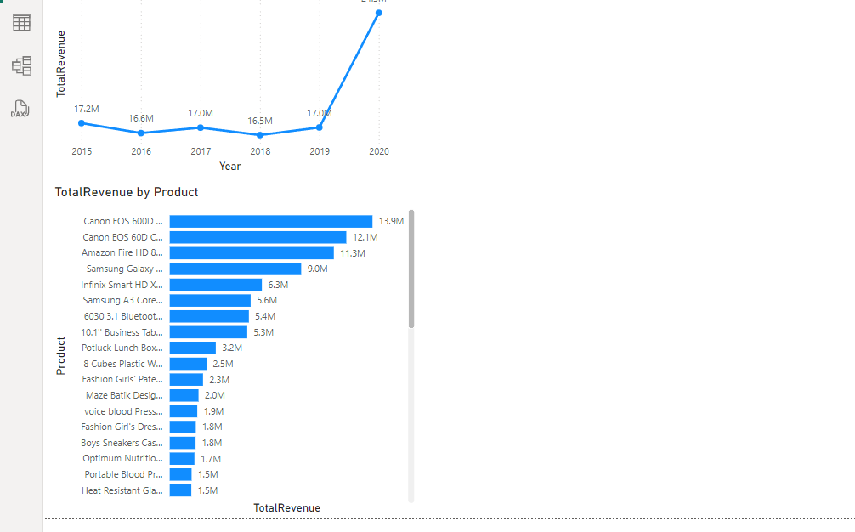

**Suggestions**:

* Increase marketing efforts for low-selling items as shown in graph which are at the bottom.
* Bundle low-performing products with popular ones. This strategy can encourage customers to purchase the low-performing item alongside the popular one, potentially increasing its sales.
* Use customer feedback to improve product features or descriptions.

1. **How many products were returned? Use a DAX function to get this metric. Examine the possible reasons for returns and consider how this metric could indicate improvements in product descriptions or quality control.**

**Reference:**

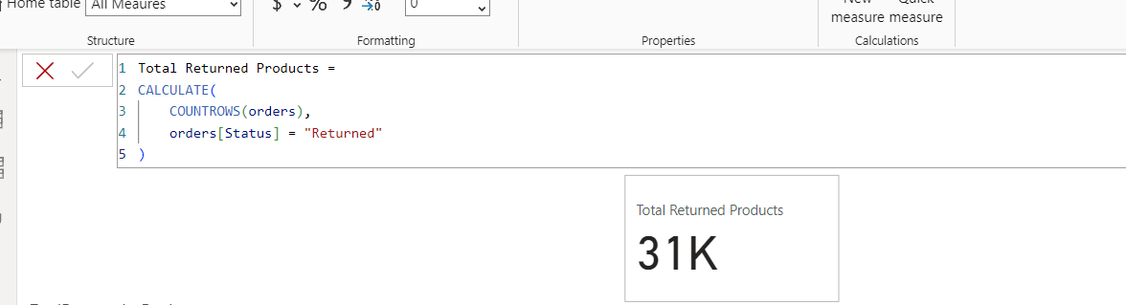

There were 31k products returned as shown above.

**Reasons for Returns:**

* Product not as described which indicates for better product descriptions or images.
* Defective items which suggests improvements in quality control.

**Suggested Improvements:**

1. **Enhance Product Descriptions**:
   * By ensuring that all relevant details (size, materials, features) are clearly listed.
   * Use of multiple images from different angles.
   * Include user-generated content, such as photos and testimonials, to provide a more realistic representation of the product.
2. **Quality Control Measures**:
   * By implementing stricter quality control checks before products are shipped.
   * Creating a system for collecting and analyzing customer feedback on product quality to continually refine processes.
3. **Whenever a customer goes to Amazon, they’ll filter the most rated products to buy the better category. Can you verify this using any visualization or table that the ratings of products impact their sales value?**

**Visualization:**

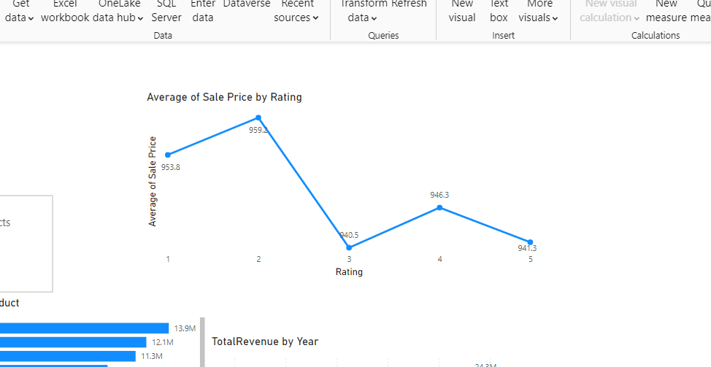

**Insights:**

* Customers are likely to filter for highly rated products, as indicated by the significant sales increase for products rated above 4. This suggests that ratings significantly influence purchasing decisions.
* Focusing marketing efforts on products with higher ratings can enhance sales.
* Products with lower ratings should be analyzed for potential improvements like customer reviews can provide insights into issues that need addressing, which can boost ratings as well as sales.

1. **Investigate how revenue distribution varies across different locations. Explore which geographical areas contribute most to sales and consider the strategic implications for regional marketing and distribution efforts. How might location-based trends inform the company's market segmentation and resource allocation approach?**

**Visual Representation**:

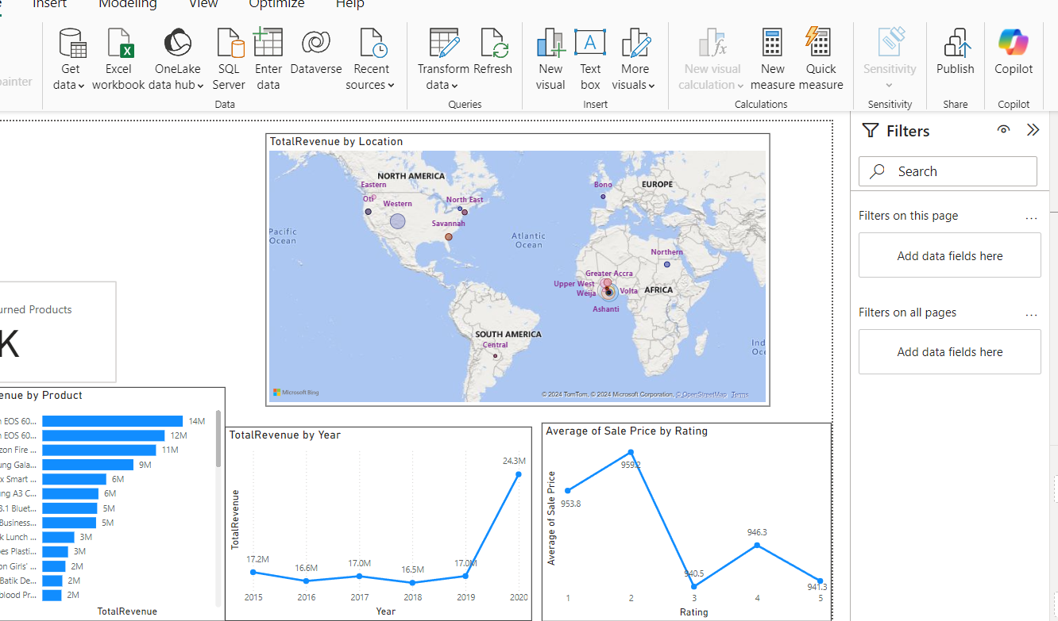

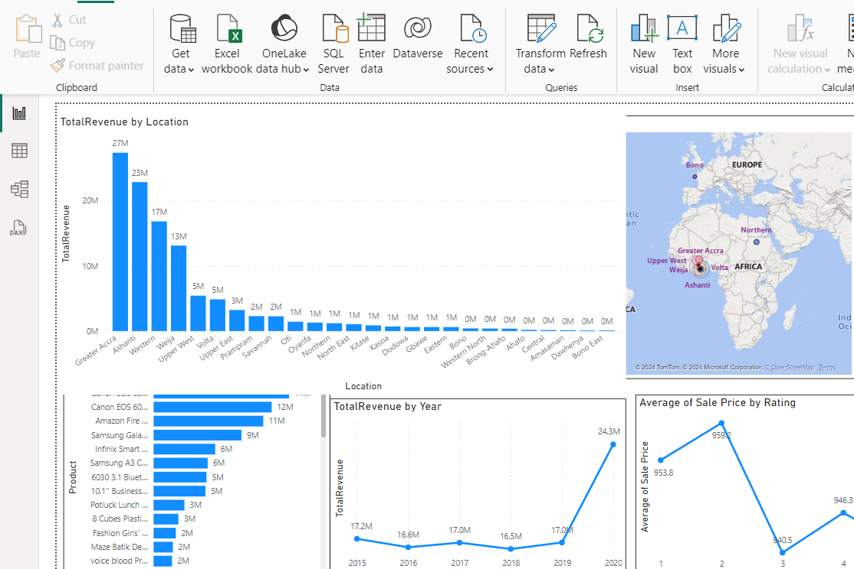

**Insights:**

* Greater Accra stands out as the highest revenue-generating region with 27M. This suggests that it is a critical market for business.
* Other contributors like Upper West and Eastern regions also generate significant revenue, indicating multiple strong markets.
* Low Revenue Areas from Oti show relatively low revenues as shown above. This highlights potential areas for improvement or targeted marketing efforts.

Location-based trends can significantly inform a company's market segmentation and resource allocation strategy in several ways:

* By analyzing revenue data by location, the company can identify which regions contribute the most to overall sales.
* Variations in purchasing behaviour across locations can lead to the development of localized versions of products or services to better meet customer expectations.
* Understanding geographical revenue distribution can help in planning logistics and distribution strategies, ensuring that high-demand areas are well-stocked while optimizing inventory levels in less productive regions.

1. **Determine which month could benefit from enhanced promotional offers to boost sales. Can you suggest some targeted marketing strategies here?**

**Reference:**

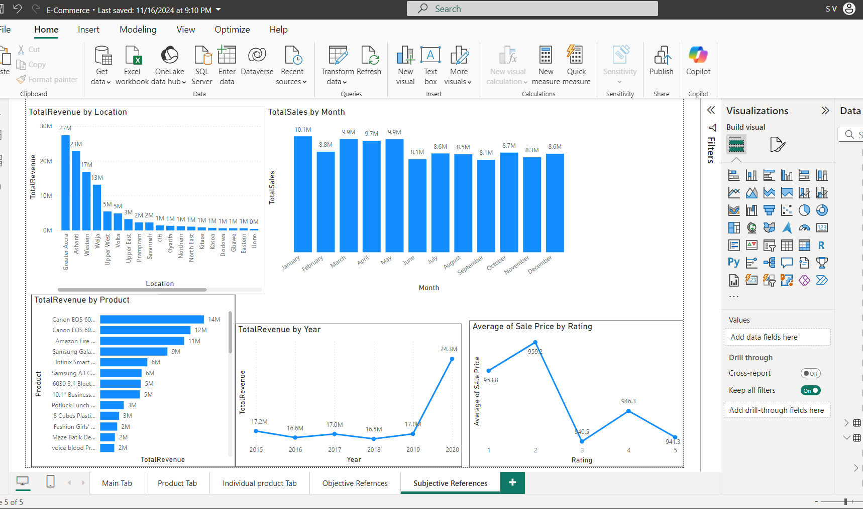

**Insights:**

* January (10.1M) has the highest sales and doesn't require boosting.
* June(8.1M), September(8.1M) and November(8.3M) represent sales dip below the average(9M) and should be targeted for enhanced promotions.
* July, August, October, and December show consistent but lower-than-ideal sales that can benefit from specific seasonal promotions.

**Targeted Marketing Strategies:**

* **For June and September**: Focusing on summer sales, and back-to-school promotions.
* **For October**: Start building a holiday momentum with early bird offers, Halloween promotions, and sneak peeks of upcoming sales events.
* **For November and December**: Focusing on Black Friday, last-minute gift deals, "12 Days of Christmas" offers, gift bundles, and loyalty rewards to maximize end-of-year sales.

1. **Identify which products may require increased marketing efforts. Which items have high prices yet underperform in sales?**

**References:**

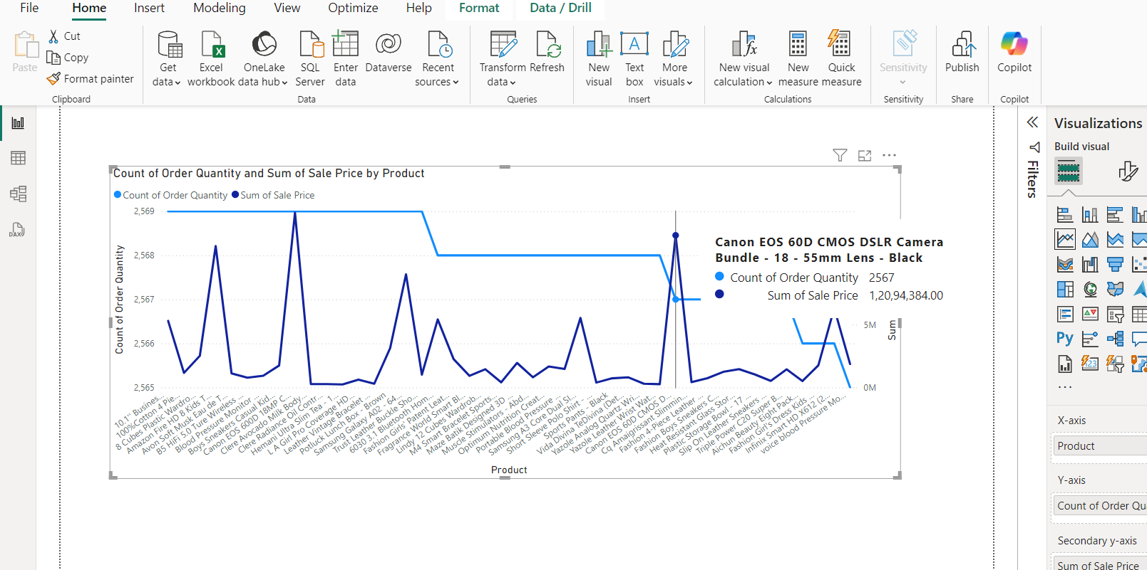

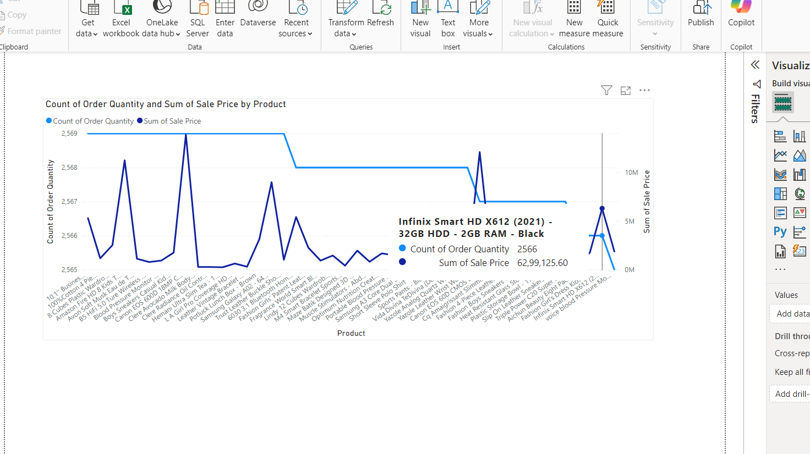

* After analysing the product performance data, two items stand out as having high prices but underperforming sales as shown in above references.
* These two products are priced higher than most competitors in its category but has not shown strong sales figures. It is possible that customers perceive it as overpriced or are unaware of its value proposition.
* This combination suggests that these products may benefit from targeted marketing interventions to drive demand and justify their pricing.

**Strategies for increasing marketing:**

* For expensive products, emphasize their quality, features, and exclusive offers.
* Offering limited-time promotions, bundles, or loyalty discounts may incentivize buyers to try the product despite the price tag.
* Revisit the pricing strategy. If this product is priced similarly to competitors but lacks distinct advantages, adjusting the price slightly or improving its features may help boost sales.

1. **Assess which products should have discounts. How can targeted incentives drive sales and customer loyalty for specific products?**

**References:**





**Insights:**

* As shown in above figure, we have 2 products i.e

Canon EOS 60D DSLR Camera Bundle-18-55mm lens-Black and Infinix Smart HD X612(2021)-32GB-2GB RAM- Black, where sales are high in price and less in order quantity.

* Products with a high price tag but low quantity volume can be seen as too expensive by customers. Offering a targeted discount can help make these products more appealing to buyers who might hesitate to pay full price.

**Recommendations:**

* Targeted incentives, like time-limited offers or exclusive deals, create a sense of urgency, motivating customers to buy now.
* Offering discounts to customer preferences or purchase history can encourage hesitant buyers to make a purchase.
* Discounts or rewards on specific products can draw attention to items that may not be selling well, increasing their visibility and sales.

1. **Come up with a loyalty program to benefit the company’s customers. From the available lot of customers come up with strategies to bucket them and provide benefits under different loyalty programs.**

A loyalty program can be based on purchase frequency, total sales, order quantity, or customer ratings.

**Reference:**

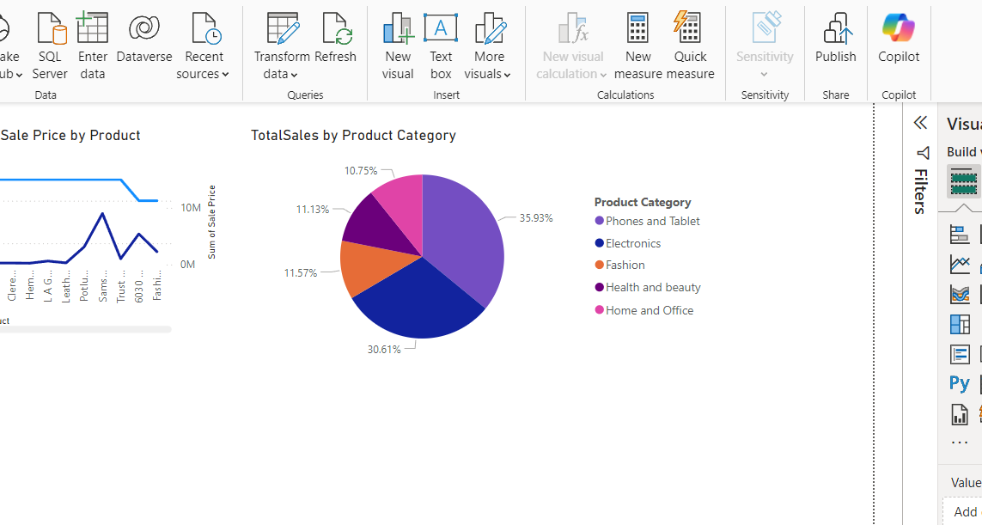

**Loyalty Program Ideas:**

1. **Tiered Rewards for Top Categories:** Offer special incentives for customers who regularly purchase from high-performing categories. For example, as we can see Phones and Tablet represents 40% of total sales, so we can provide extra points, exclusive discounts, or early access to sales for customers who buy within this category.
2. **Seasonal Loyalty Offers**: Launch targeted loyalty rewards during peak seasons for specific categories. For example, during the holiday season, offer extra points or discounts on categories to increase sales during that time.
3. **Referral Rewards for Top Categories**: Rewards for customers who refer friends and family could earn loyalty points or discounts on high-demand categories.
4. **Using the DAX functions Calculate and a row iteration DAX function calculate the total sales for the Product Category “Fashion” and delivery type “Shipped from Abroad”. What are the other types of DAX functions you have used in the project?**

**Reference:**

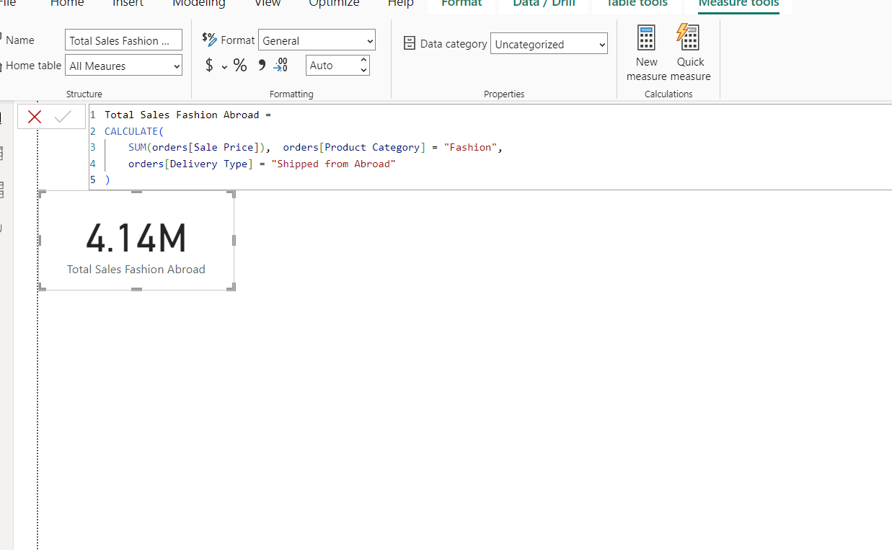

**Other DAX Functions:**

* **SUMX**: Iterates over a table and sums the expression for each row.



* **DISTINCTCOUNT**: Counts the number of unique, non-blank values in a specified column.





* **AVERAGEX**: Calculates the average over a table or expression.
* **FILTER**: Returns a table that represents a subset of another table based on a condition.
* **DATEDIFF**: Calculates the difference between two dates in a specified unit (e.g., days, months, or years).



* **CALCULATE**: Modifies the context of a calculation and evaluates an expression based on filters or conditions.
* **COUNTROWS**: Returns the number of rows in a table or table expression.



* **AVERAGE**: Calculates the average of a column.
* **ALLEXCEPT:** Removes filters from all columns in a table, except for the specified columns.

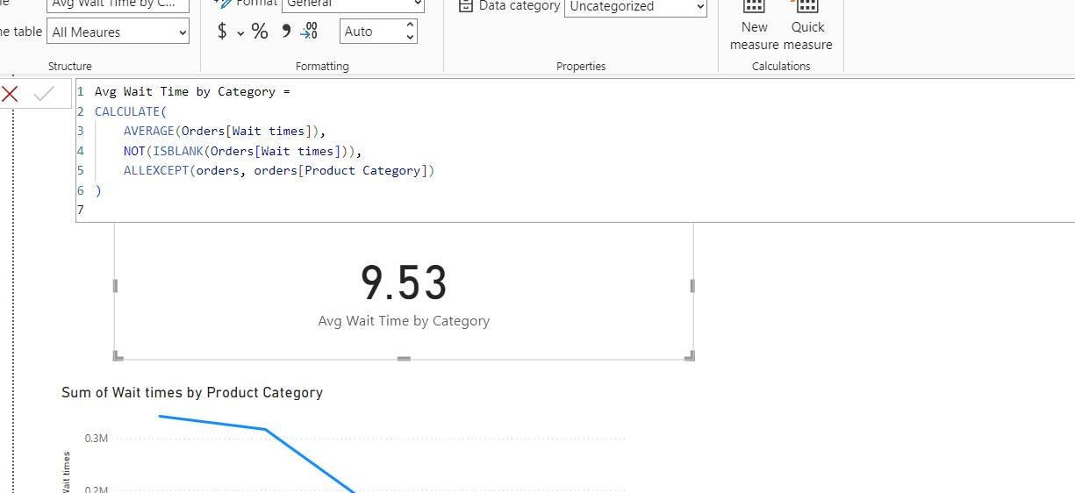

* **SAMEPERIODLASTYEAR**: Compares the current period with the same period from the previous year.

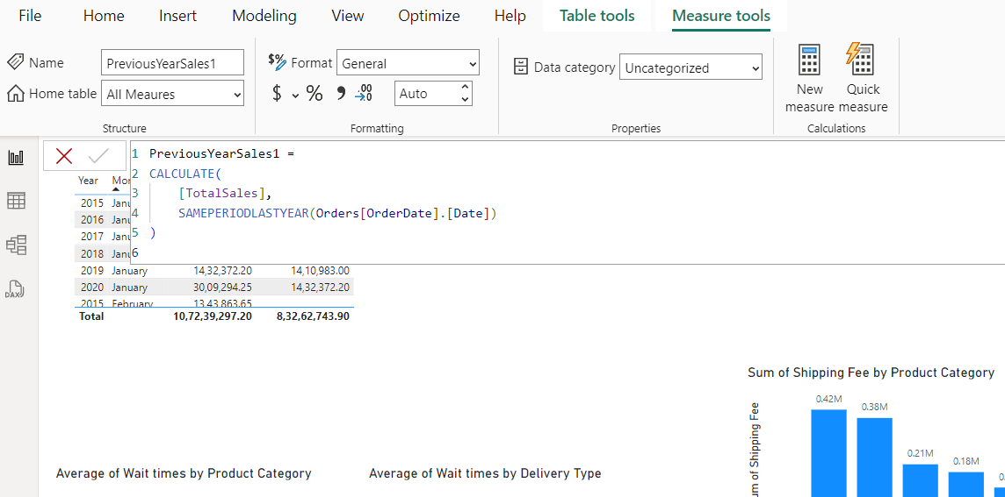

1. **Wait Times Correlated with Demographics and Care: Explore how average wait times vary across different product categories to optimize scheduling and staffing.**

**Reference:**



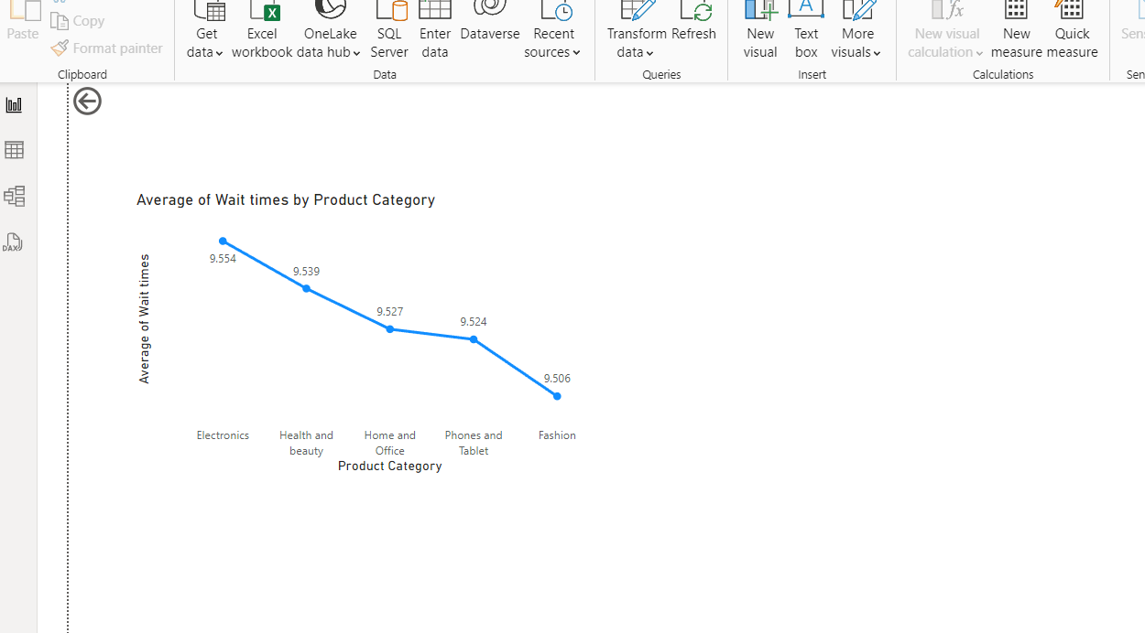

**Insights:**

* Electronics has the longest average wait time (9.554 days), suggesting that there may be inefficiencies or delays in processing orders in this category.
* Health and Beauty, although slightly higher than Home and Office, still falls into a higher category of wait times compared to others, indicating a potential issue in fulfilment processes for this category.
* Fashion, Phone and Tablets, and Home and Office have relatively closer wait times, though Fashion still has a lower average compared to the others, indicating a more efficient processing system for this category.

**Strategies to optimize scheduling and staffing:**

* Allocating more staff or optimize fulfilment processes to reduce delays in this Electronics category.
* Ensuring the current staff levels are maintained but be prepared to scale during peak demand periods.
* By leveraging data to forecast high-demand periods (e.g., holidays) and adjust staffing levels to ensure timely order fulfilment across all categories.

1. **Explore if there is any relationship between the Delivery type and waiting time between ordering and receiving an item.**

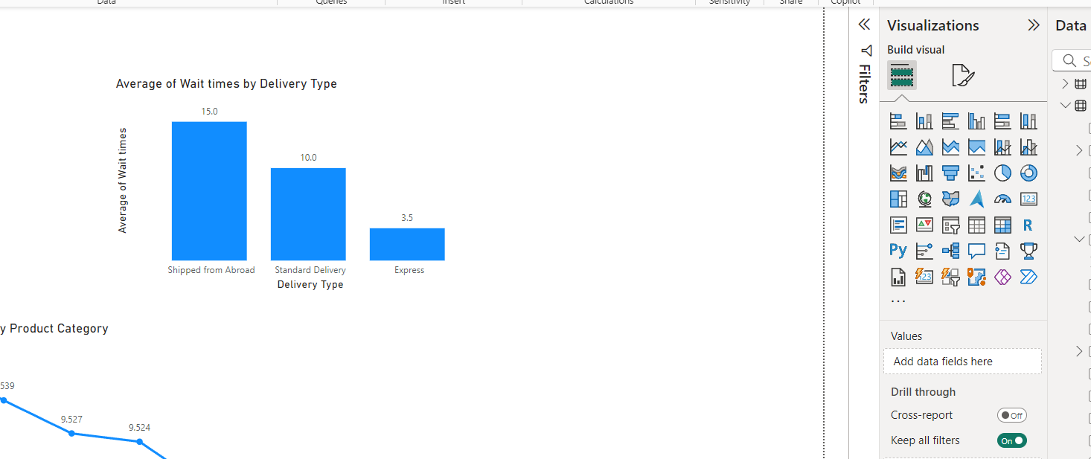

**Insights:**

* Shipping from Abroad has the highest average wait time (15.0 days), indicating that international shipping or logistics may be causing significant delays. This could be due longer transit times, or limited shipping options.
* Standard Delivery has a moderate wait time of 10.0 days, suggesting that domestic deliveries take a reasonable amount of time but may still have room for improvement.
* Express Delivery has the shortest wait time (3.5 days), which is ideal for customers who value quick delivery. However, since it’s significantly faster, it might suggest that customers are willing to pay a premium for faster service.

**Recommendations:**

* Partner with faster international carriers to reduce the long wait times for Shipped from Abroad.
* Improve customs clearance processes to minimize delays in international shipments.
* Prioritize Express Delivery during peak times to maintain the quick 5-day delivery window.
* Use better tracking systems to keep customers informed about their orders and manage expectations.
* Adjust staffing levels based on demand for different delivery types, particularly during peak seasons, to avoid delays.

1. **Is there any relationship between shipping charges and product type?**

**Reference:**

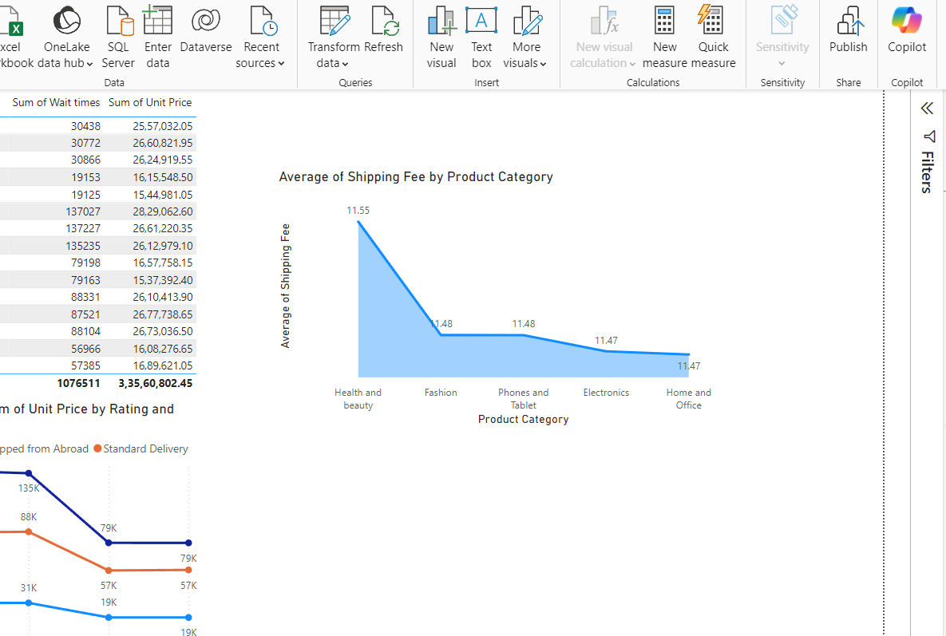

**Insights:**

* The shipping charges for all the product types are almost identical, ranging from 11.47 to 11.55. This indicates that the shipping charges do not vary significantly across these categories in our data.
* This could imply that the company uses a standardized shipping fee regardless of the product type, which is common in e-commerce businesses where flat-rate shipping fees are applied for convenience.
* The minimal difference suggests that the shipping fees are either fixed or determined by factors other than the product type, such as the size, weight, or delivery location, rather than the product's category.

1. **Come up with strategies to decrease the low rating orders after analyzing different factors like waiting time, shipping type, unit price, etc.**

**Reference:**

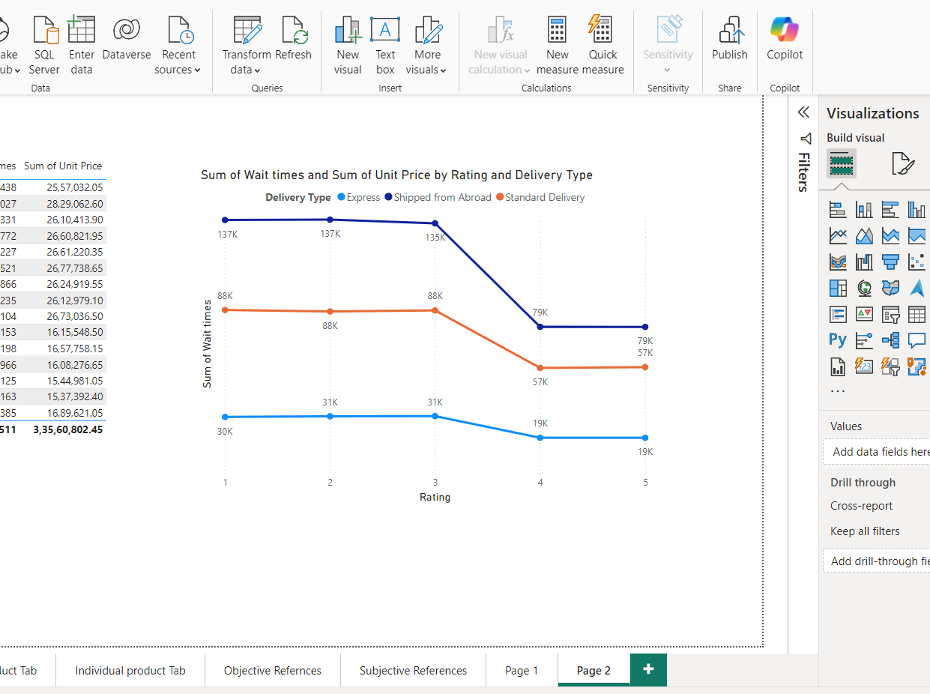

**Insights:**

* Longer wait times are associated with lower ratings, particularly for Express and Shipped from Abroad deliveries.
* Express Delivery maintains relatively high ratings despite longer wait times, indicating that customers value speed.
* Standard Delivery with average wait times, leads to better ratings and suggesting customers appreciate faster delivery.
* Low ratings with short wait times, have factors beyond delivery speed, such as product quality or customer service, may also be influencing customer satisfaction.
* To improve overall ratings, focus on reducing wait times while also addressing other factors like product quality and customer service as mentioned above.

1. **Using the time intelligence DAX function, create a table to compare each month’s sales with the previous year’s same month’s total sales. So there will be four columns in the output year, month, total sales, previous_years_sales.**

**Reference:**

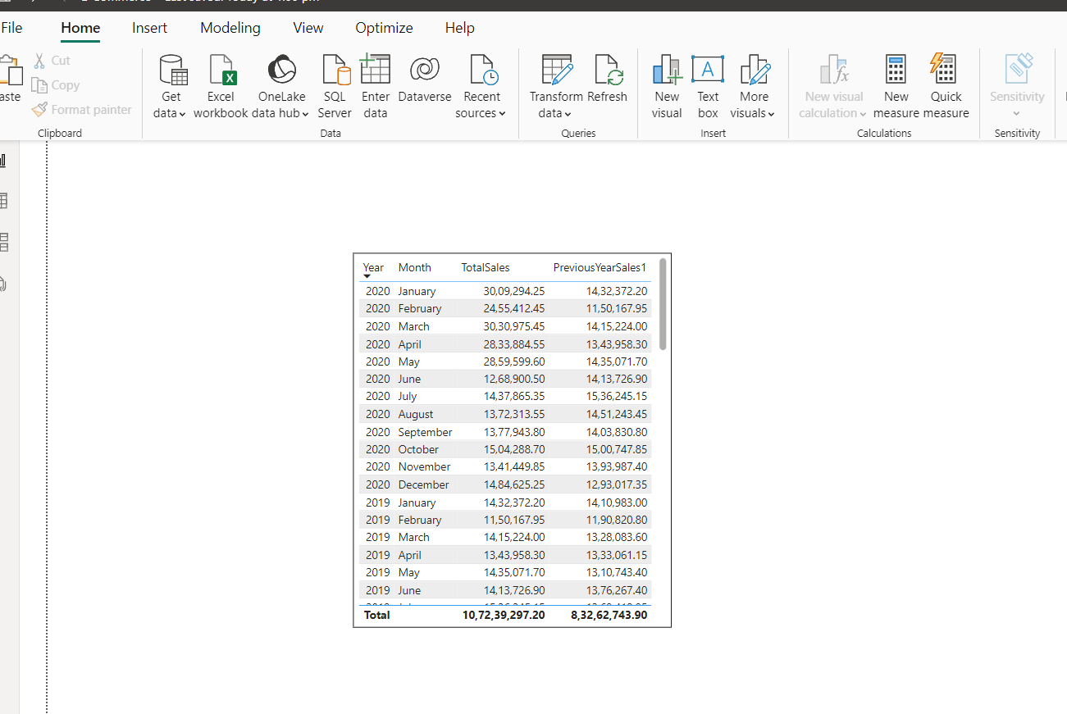

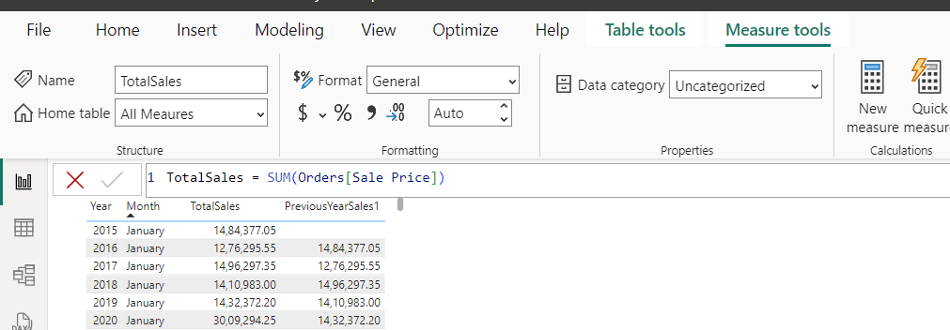



The DAX functions used are

* **SAMEPERIODLASTYEAR**: This function shifts the context to the same period in the previous year, making it easy to compare year-over-year performance.
* **SUM**: This function is used to sum the sales of that column.

1. **What do you understand by Power BI gateway? What are its use cases?**

* Power BI Gateway is a bridge between on-premises data sources and Power BI in the cloud. It allows to schedule refreshes, connect to local databases, and ensure that Power BI reports are up-to-date.

**Use Cases of Power BI Gateway:**

* **On-Premises Data Integration:** For businesses with on-premises databases, the gateway enables seamless data transfer.
* **Real-Time Data:** Power BI Gateway allows you to provide real-time analytics.
* **Security:** Ensures secure data transfer between on-premises and cloud services.
* **Hybrid Data Scenarios**: Organizations can manage data both in the cloud and on-premises. The gateway supports hybrid setups, making it easier to analyze data across different environments.
* **Integration with Other Services**: It can be used with other Microsoft services like Azure Analysis Services and SQL Server Analysis Services, allowing for a seamless integration of analytics solutions.

1. **How would you approach this problem, if the objective and subjective questions weren't given?**

If objective and subjective questions weren't provided in the given problem statement, here’s how I would approach the task:

**Step 1 (Data Exploration)**:

I will start by exploring the dataset. Check the summary statistics to understand key trends. Look for missing values and handle them appropriately. Clean the data by standardizing categories and correcting any inconsistencies.

**Step2 (Business Objective)**:

Focusing on the objectives like boosting sales, optimizing delivery times, improving customer satisfaction, or enhancing product offerings and then identify the areas where business can improve its performance.

**Step 3 (Key Metrics)**:

Now by focusing on some key metrics like total sales, customer satisfaction (ratings), product performance, and delivery efficiency that will help overall business and identify areas for improvement.

**Step 4 (Dashboard)**:

Finally, creating visualizations that allow stakeholders to interact with the data.

By designing the dashboards that provide insights into sales by product, region, and time. This will help the team drill down into the data and make informed decisions.